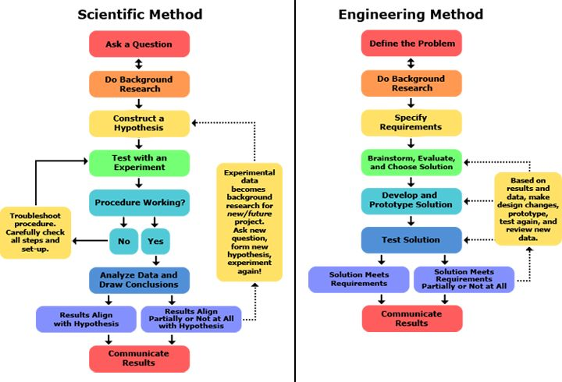

[www.sciencebuddies.org](http://www.sciencebuddies.org)